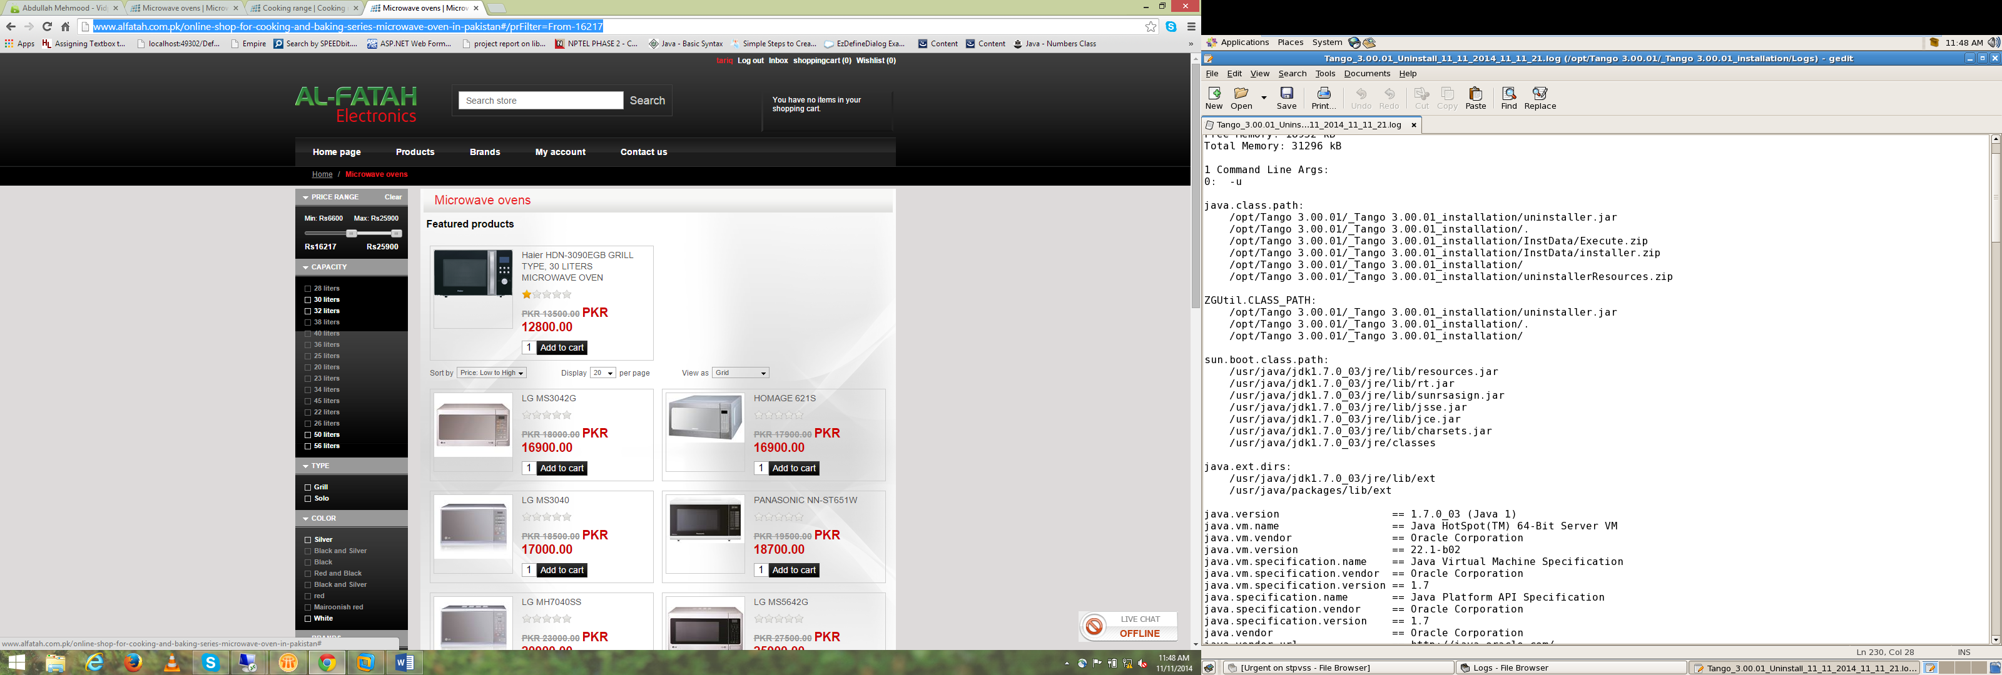

<http://www.alfatah.com.pk/online-shop-for-cooking-and-baking-series-microwave-oven-in-pakistan#/prFilter=From-16217>

Price Range dialog

* Dynamically handeled all below capacity, brand…

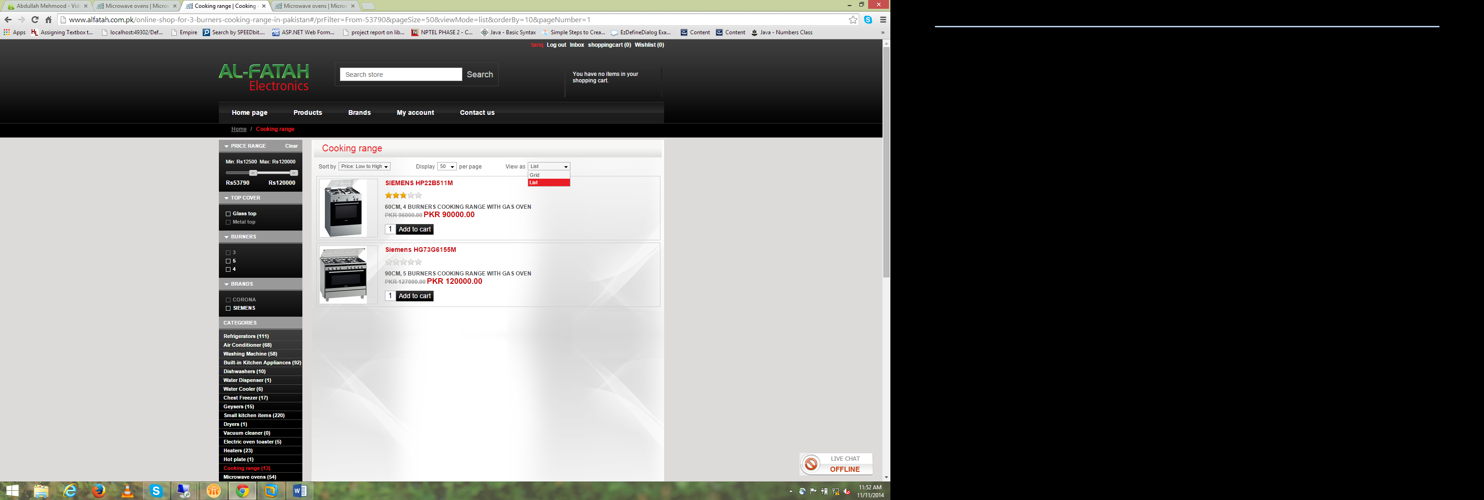

<http://www.alfatah.com.pk/online-shop-for-3-burners-cooking-range-in-pakistan#/prFilter=From-53790&pageSize=50&viewMode=list&orderBy=10&pageNumber=1>

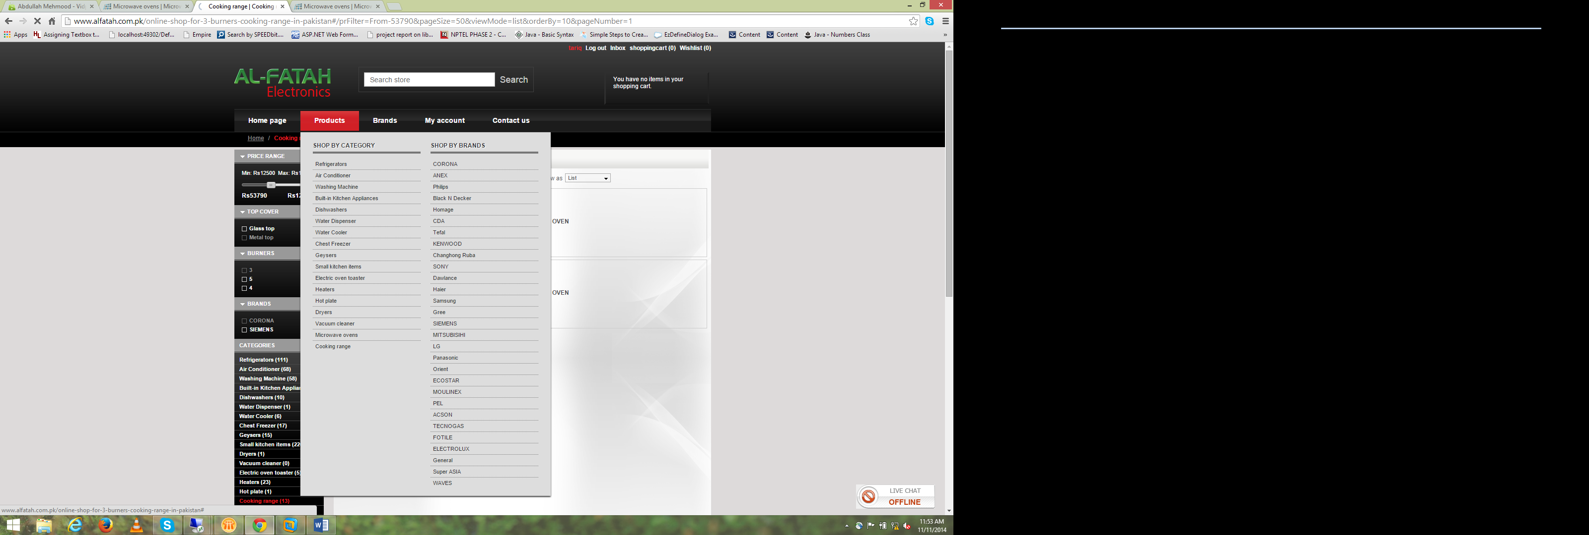

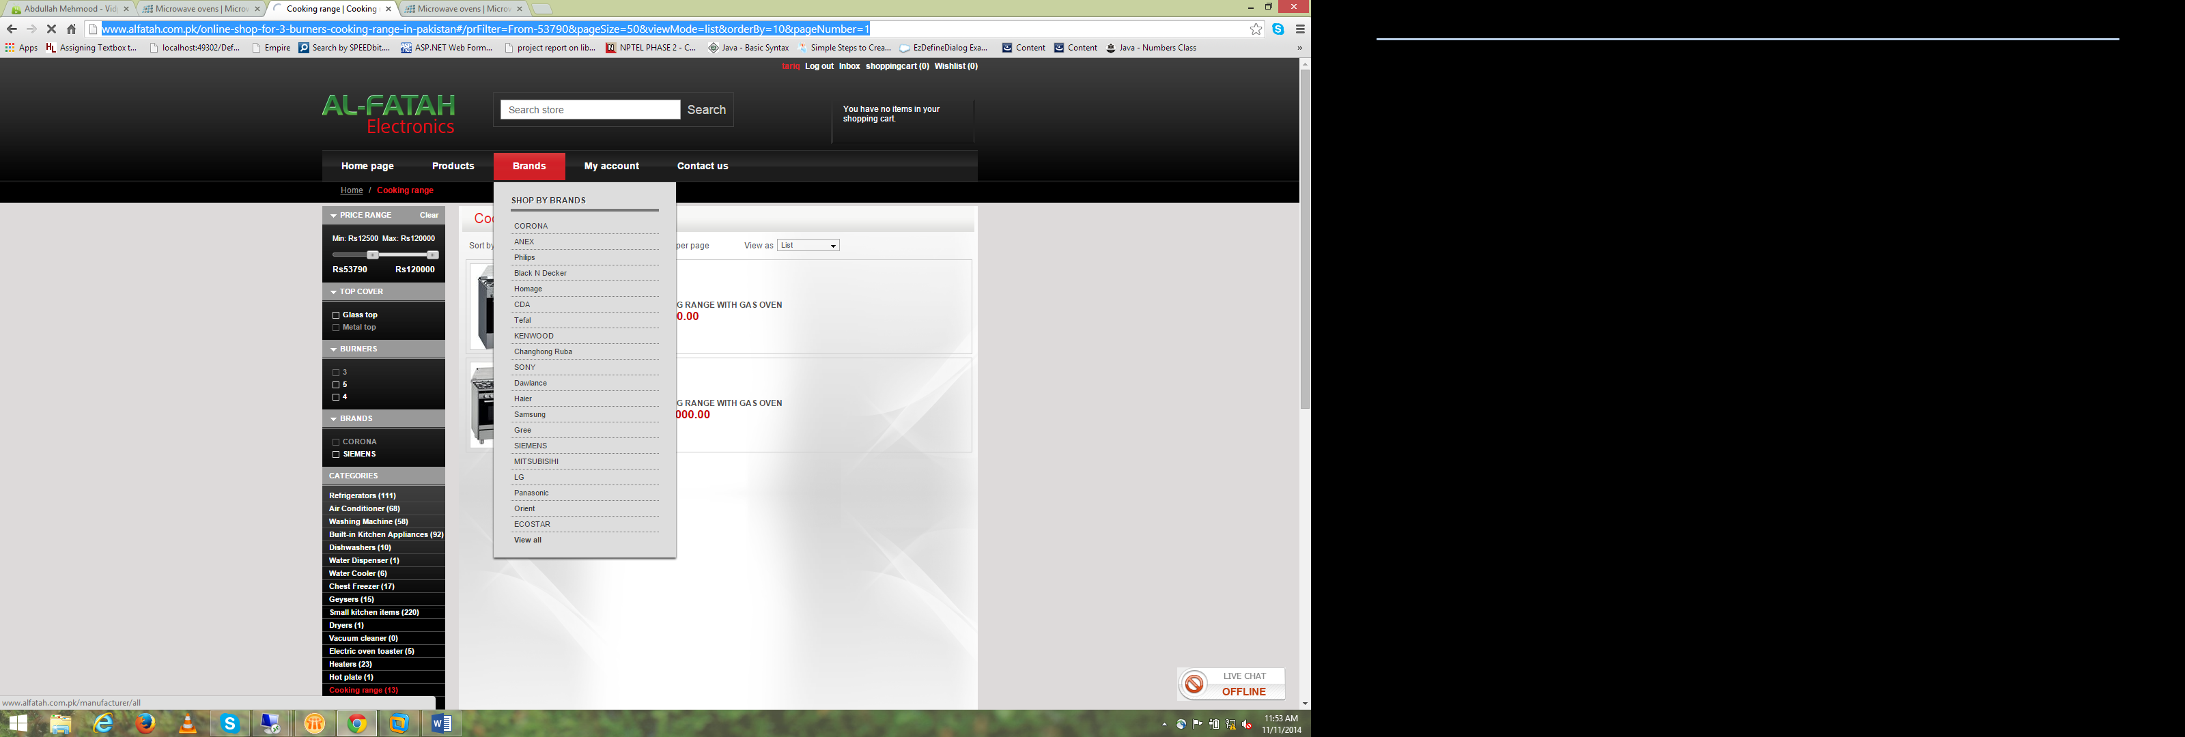

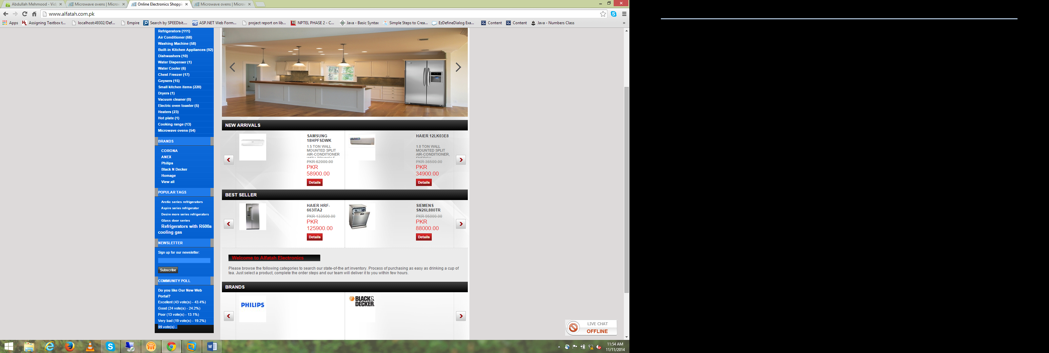

Left menu …

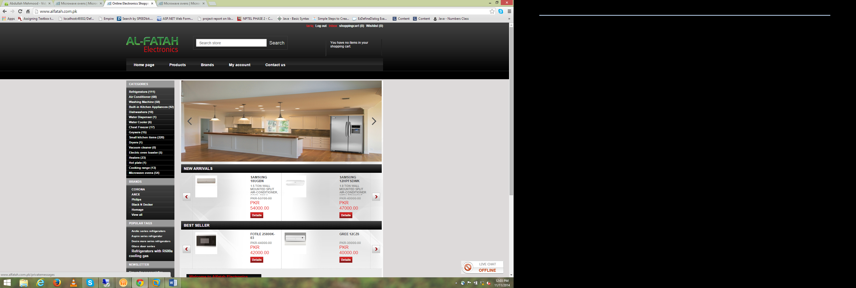

Inbox…functionality…..

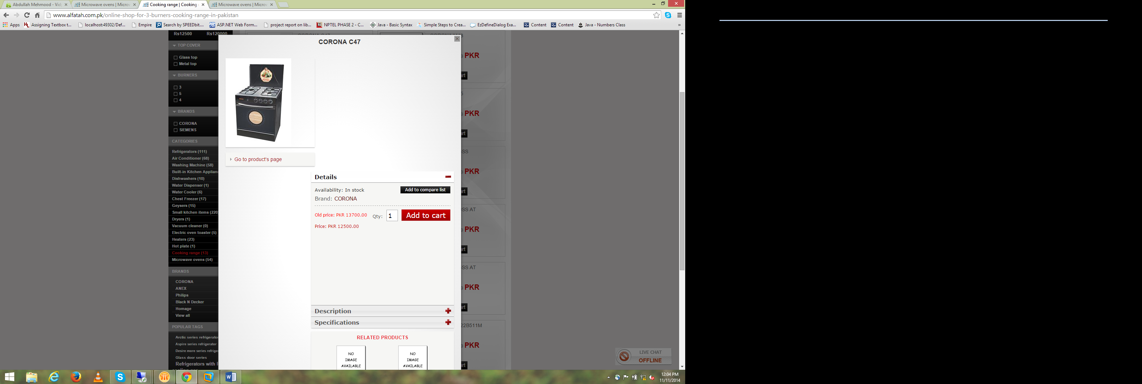

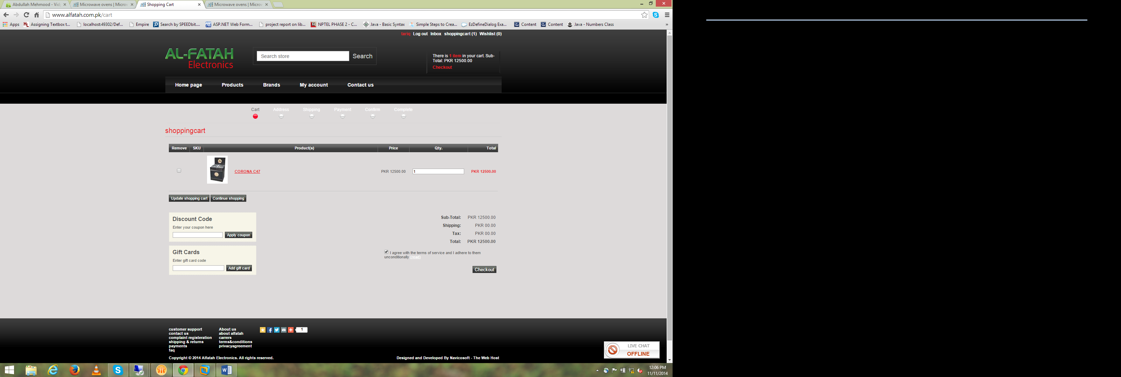

Add cart functionality

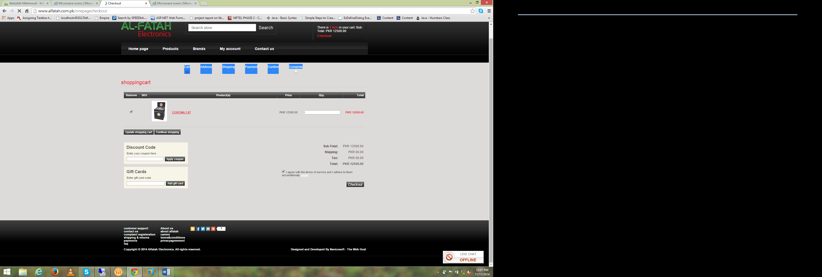

Add cart dialog functionality …select radio button ……

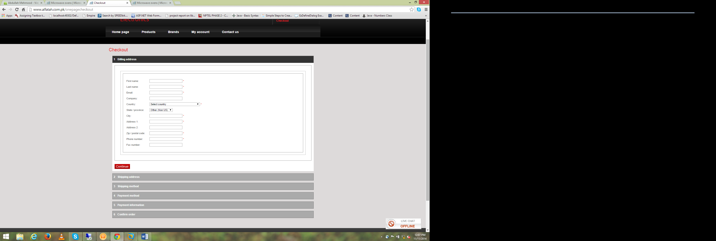

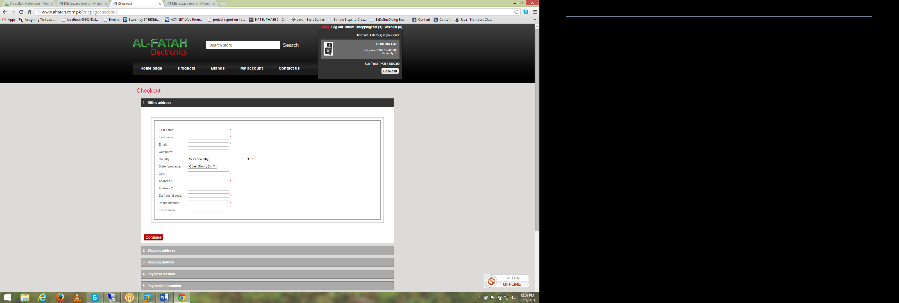

Ya screen shots hian main main in my point of view.. r in sub k lia jab tum admin panel banaho gy… to baohat time lagy ga.

Main Points

1. Admin Pannel
2. Dynamic data handling
3. Designing work
4. Client /web user feed back
5. Registerd user history maintain
6. Database

r pic k lia check kr lahein k agar db ma rkni hain to size bohat bara ho jahy ga r agar folder ma rakni hain r db ma just path daina ha to deployement k lia size increase ho jahy ga is lia deployment ki koi chez include na karna .. wo ending pa chor daina.. theak ha.. r khosish kro k us k sath updation k lia tumara contract ho jahy.